1. Write a Python program to print the following string in a specific format

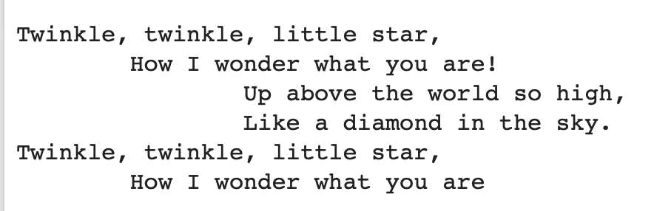

1. Write a Python program which accepts the user's first and last name and print them in reverse order with a space between them.
   1. Input: Vardenis Pavardenis
   2. Output: Pavardenis Vardenis
2. Write a Python program to calculate the number of days between two dates.
3. Write a Python program to calculate the number of days to your birthday. Enter year, month, and day in the terminal.
4. Write a Python program that will accept the base and height of a triangle and compute the area.

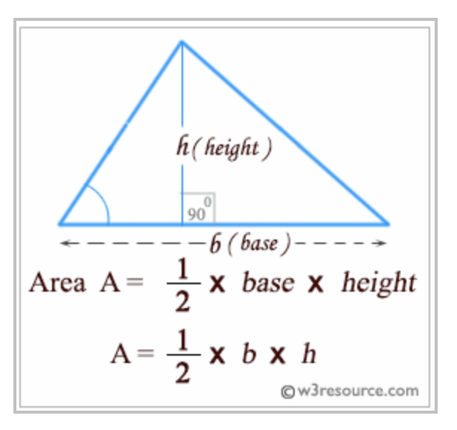

1. Write a Python program to solve (x + y) \* (x + y).

*Test Data* : x = 4, y = 3

1. Write a Python program to compute the distance between the points (x1, y1) and (x2, y2).
2. Write a Python program to get OS name, platform and release information.
3. Write a Python program to find out the number of CPUs using.
4. Write a Python program to parse a string to Float or Integer.
5. Write a Python program to convert the distance (in feet) to inches, yards, and miles.
6. Write a Python program to convert all units of time into seconds.
7. Write a Python program to calculate body mass index (BMI)
8. Given variables x=30 and y=20, write a Python program to print "30+20=50"
9. Write a Python program to check whether a string is numeric.